**Project Name :** AmAccessBiz PC2  
**Test Script ID :** AABAA_QRPay_VerifyLimit_09  
**Platform :** Windows 10  
**App Version :**   
**Run Date :** 02/27/2024  
**Run Started :** 15:44:50  
**Run Ended :** 15:47:00  
**Execution Time :** 00hrs 02mins 10secs   
**Execution Status :** Passed  
  
  
**Test Step 1(PASS) :** [BBO] Input [Username]  
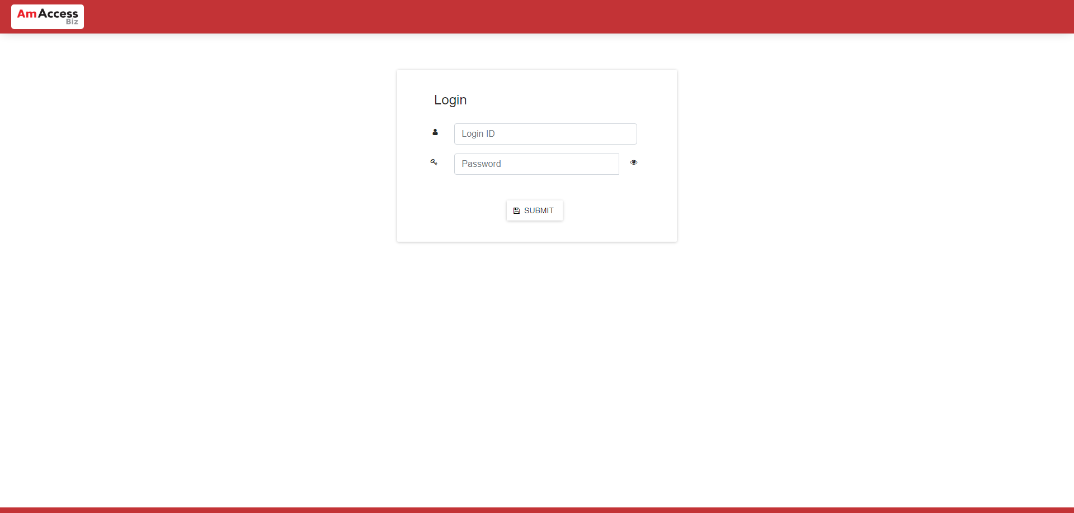  
  
**Test Step 2(PASS) :** [BBO] Input [Password]  
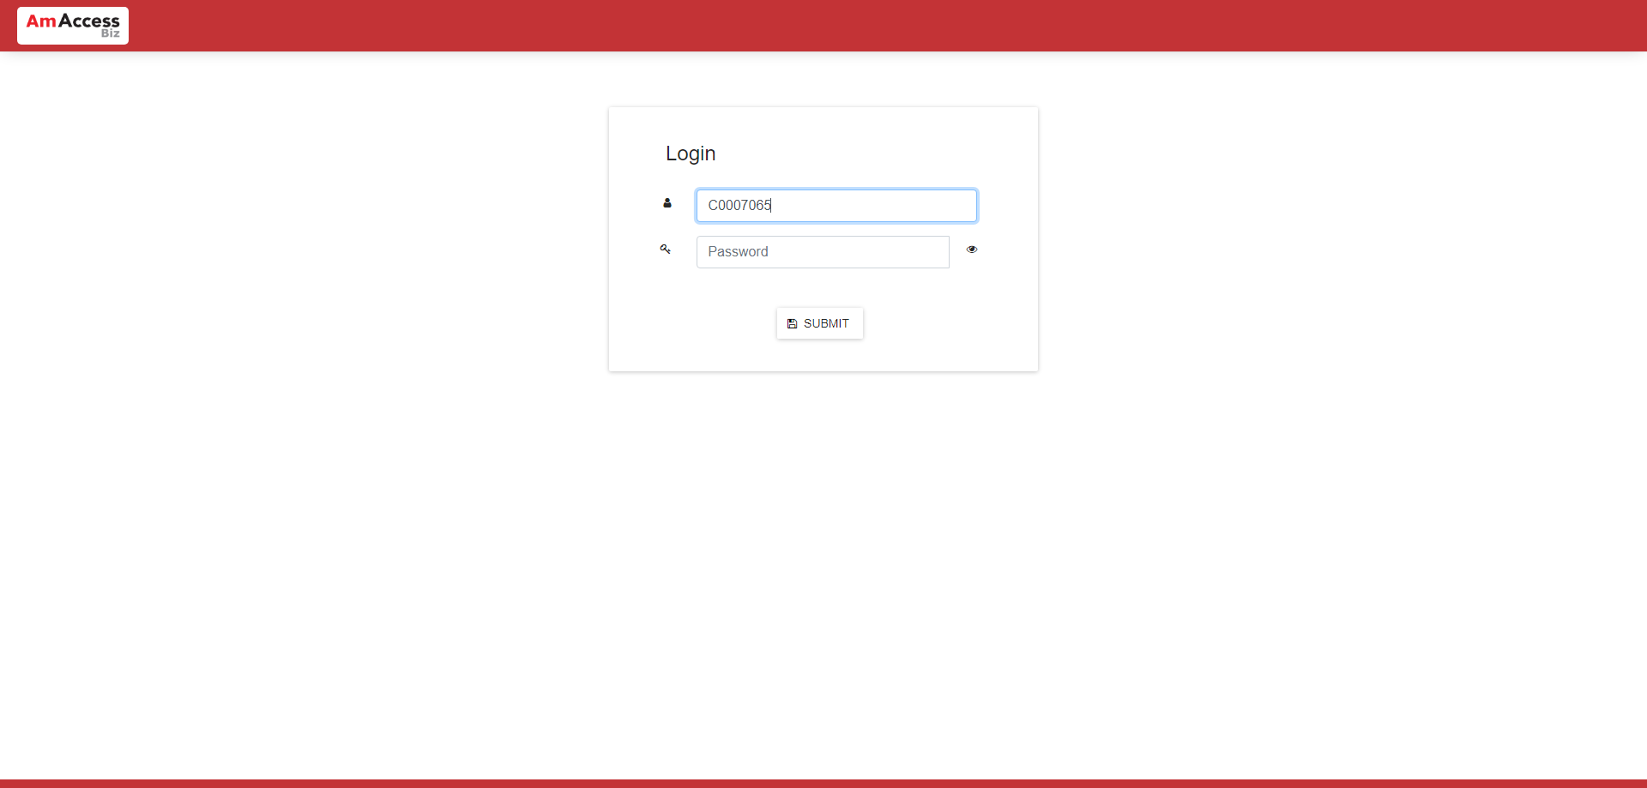  
  
**Test Step 3(PASS) :** [BBO] Click [Submit]  
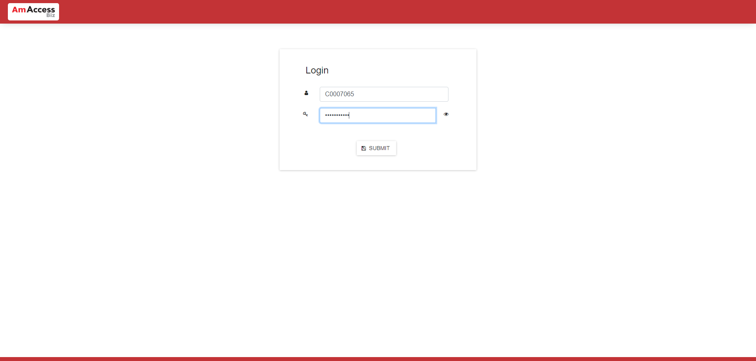  
  
**Test Step 4(PASS) :** [BBO] Click [More]  
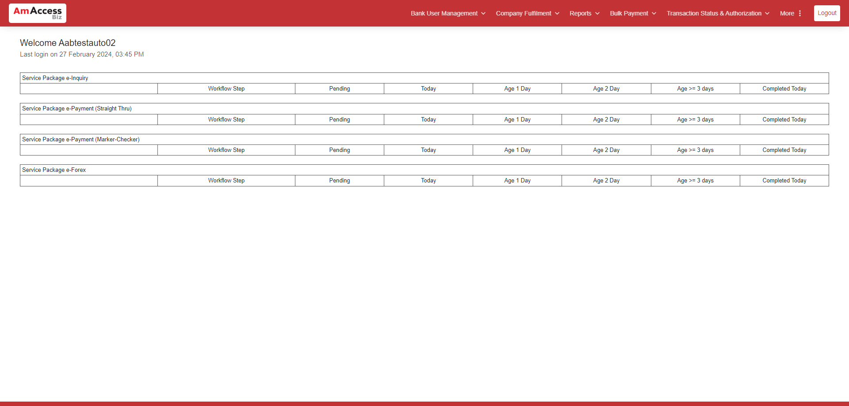  
  
**Test Step 5(PASS) :** [BBO] Click [System Parameter]  
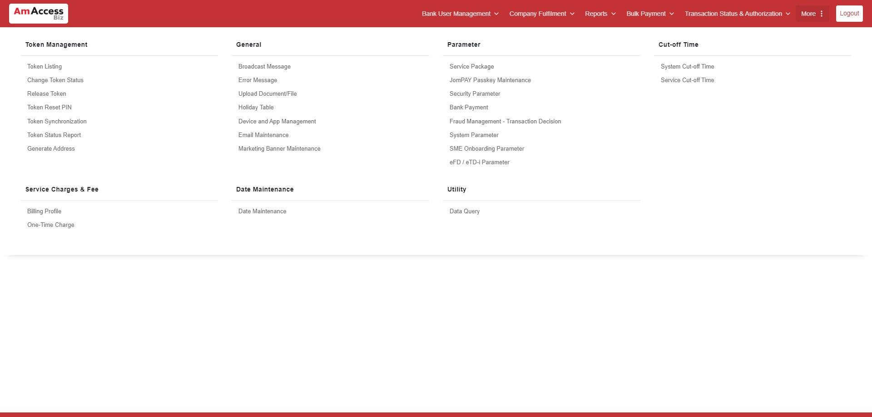  
  
**Test Step 6(PASS) :** [BBO] Verify [Duitnow Limit]  
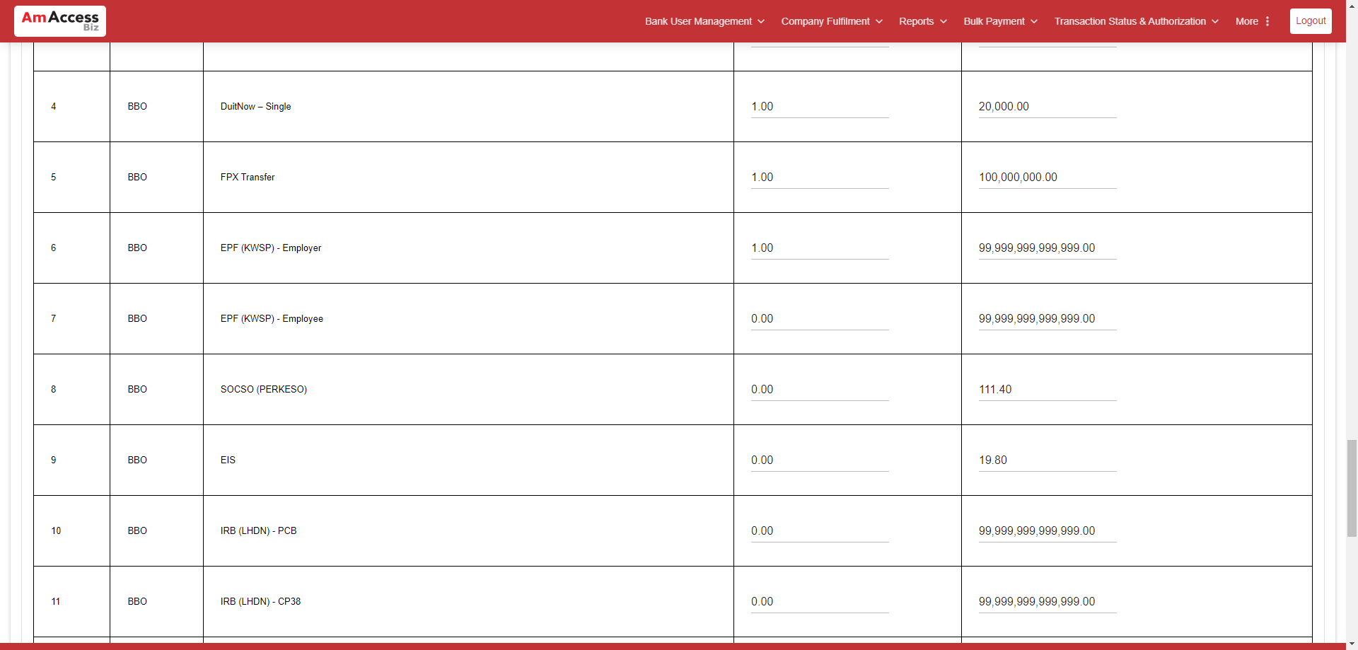  
  
**Test Step 7(PASS) :** [BBO] [Profile Information] Click [Logout]   
  
  
**Test Step 8(PASS) :** [BBO] Click [Back to Login]  
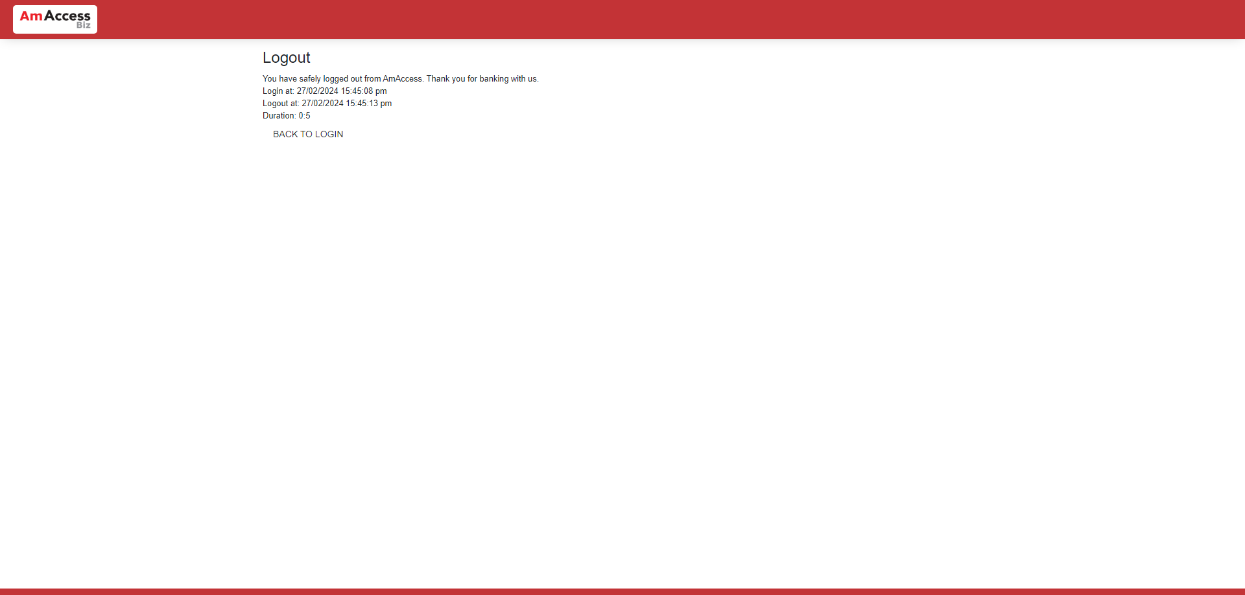  
  
**Test Step 9(PASS) :** [CFO] Input [User ID]  
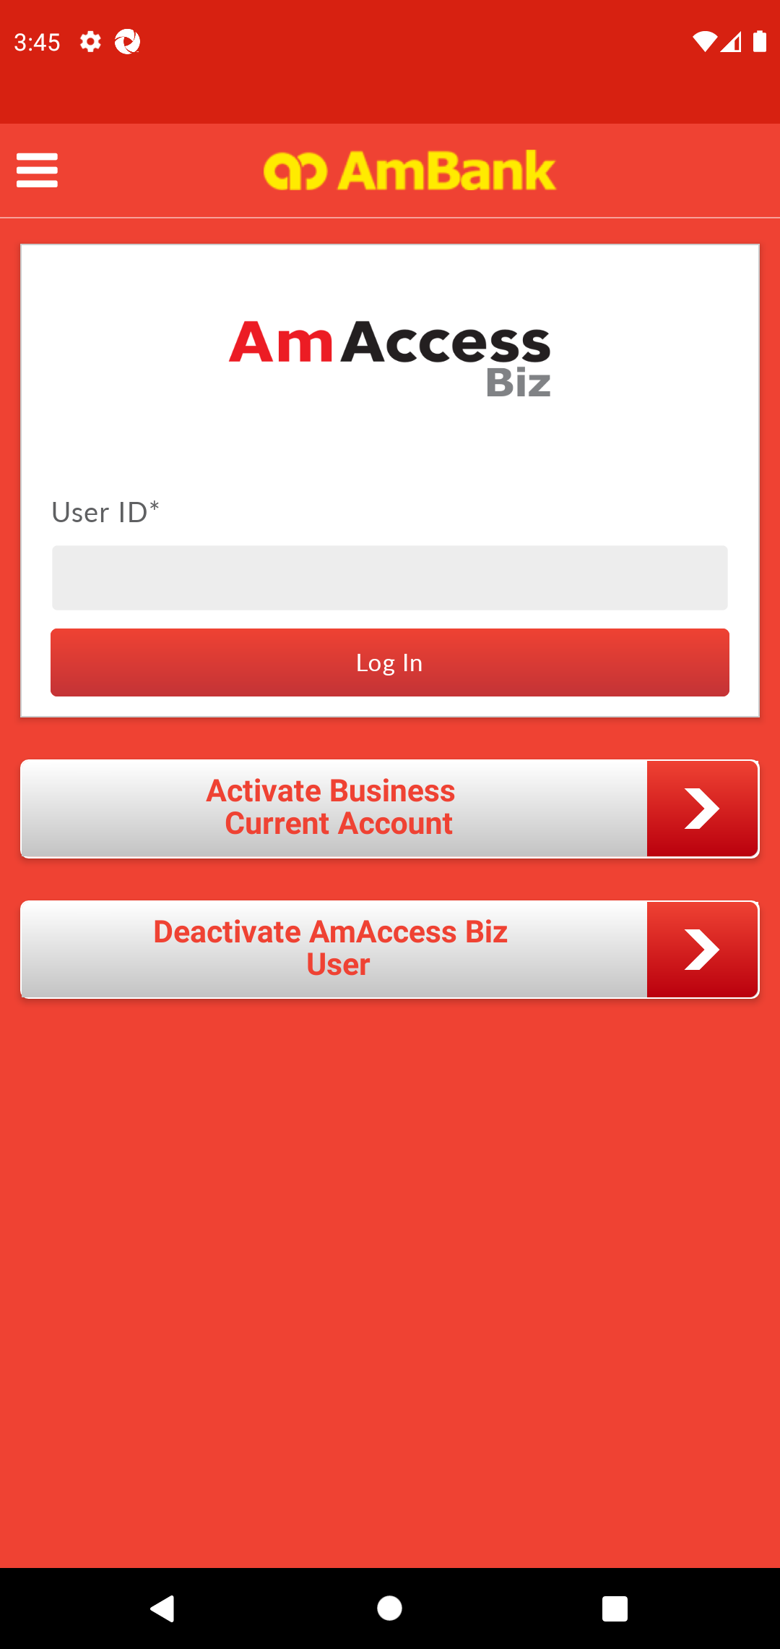  
  
**Test Step 10(PASS) :** [CFO] Click [Log In]  
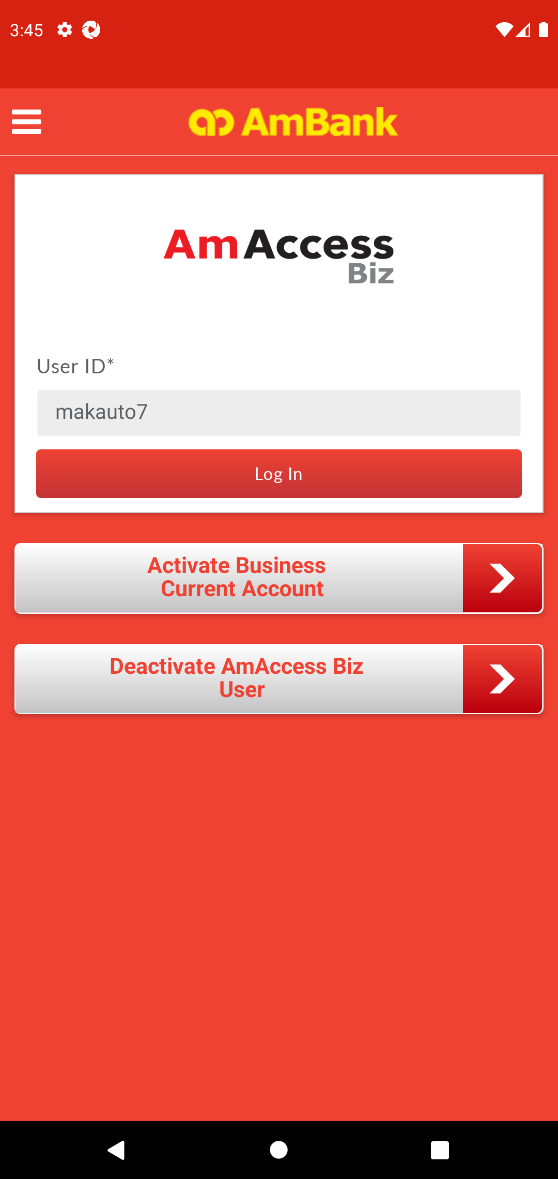  
  
**Test Step 11(PASS) :** [CFO] Click [Yes]  
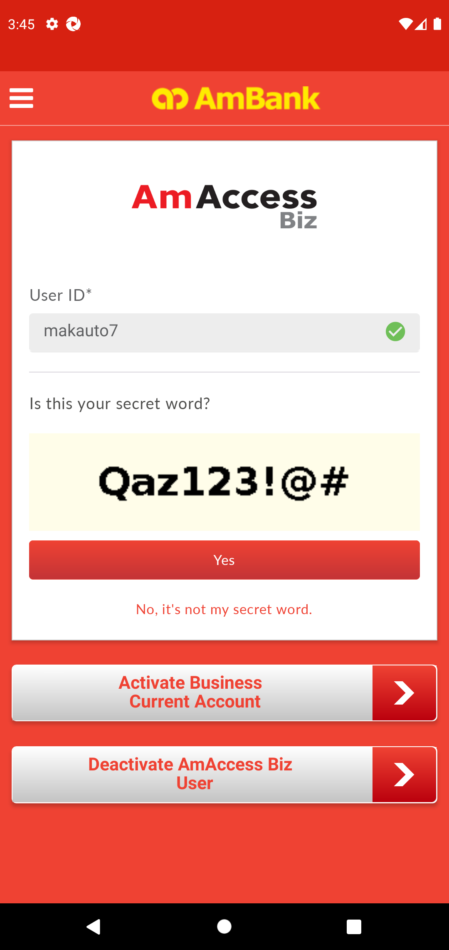  
  
**Test Step 12(PASS) :** [CFO] Input [Password]  
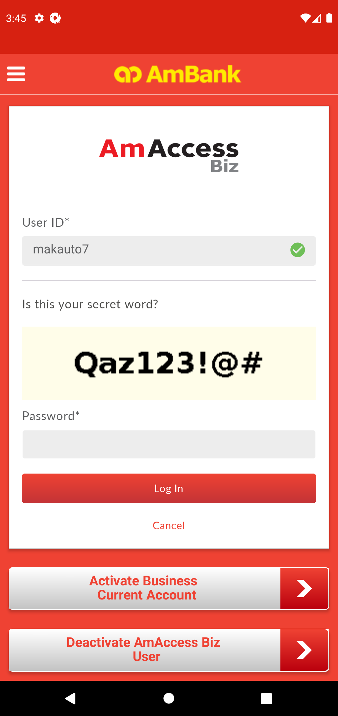  
  
**Test Step 13(PASS) :** [CFO] Click [Log In]  
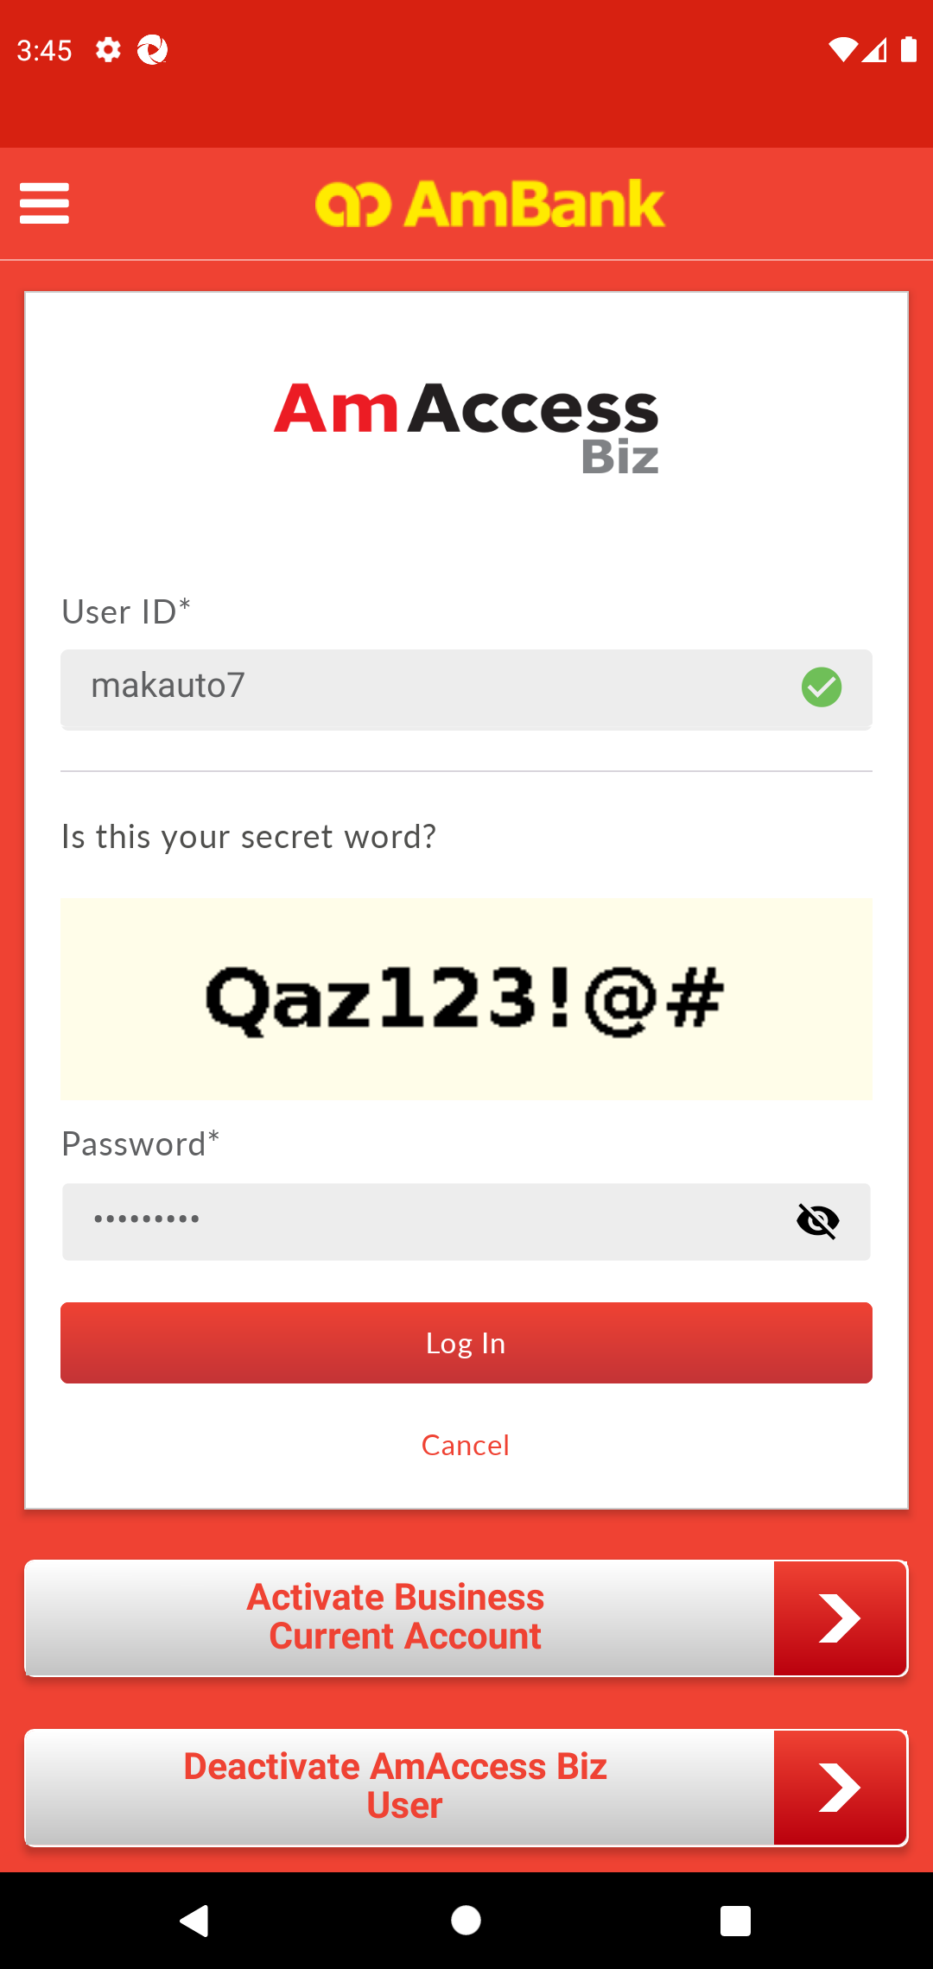  
  
**Test Step 14(PASS) :** [Home] Click [+] Button  
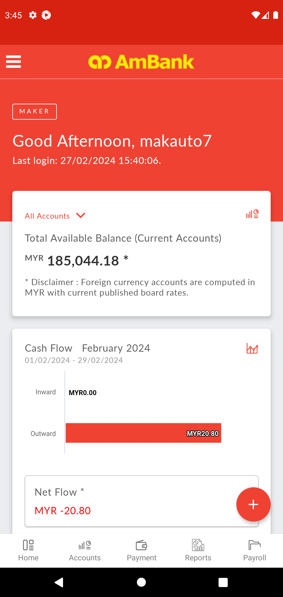  
  
**Test Step 15(PASS) :** Swipe Up  
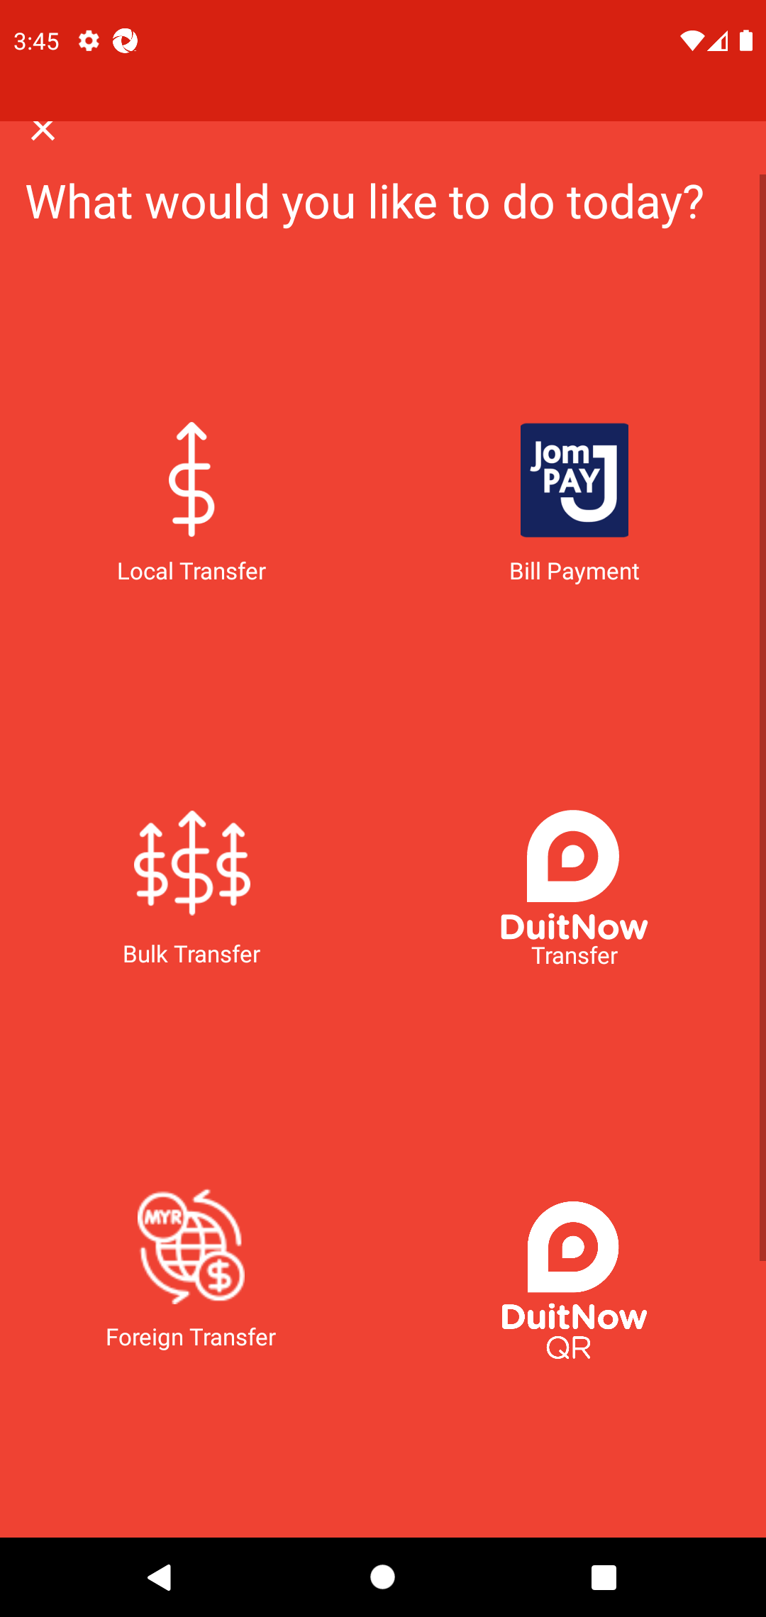  
  
**Test Step 16(PASS) :** [Home] Click [QR Pay] Button  
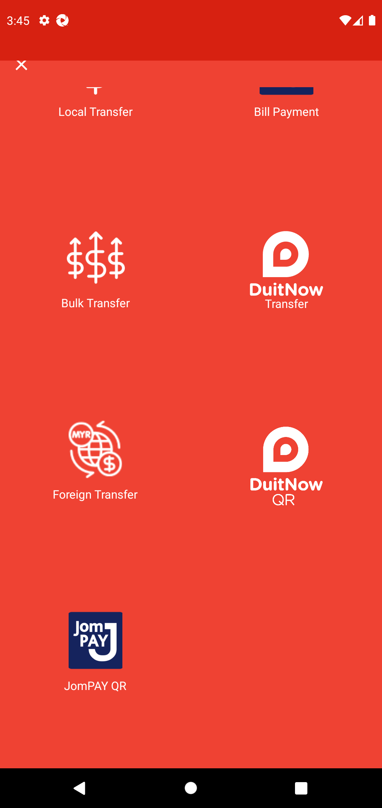  
  
**Test Step 17(PASS) :** screenshot  
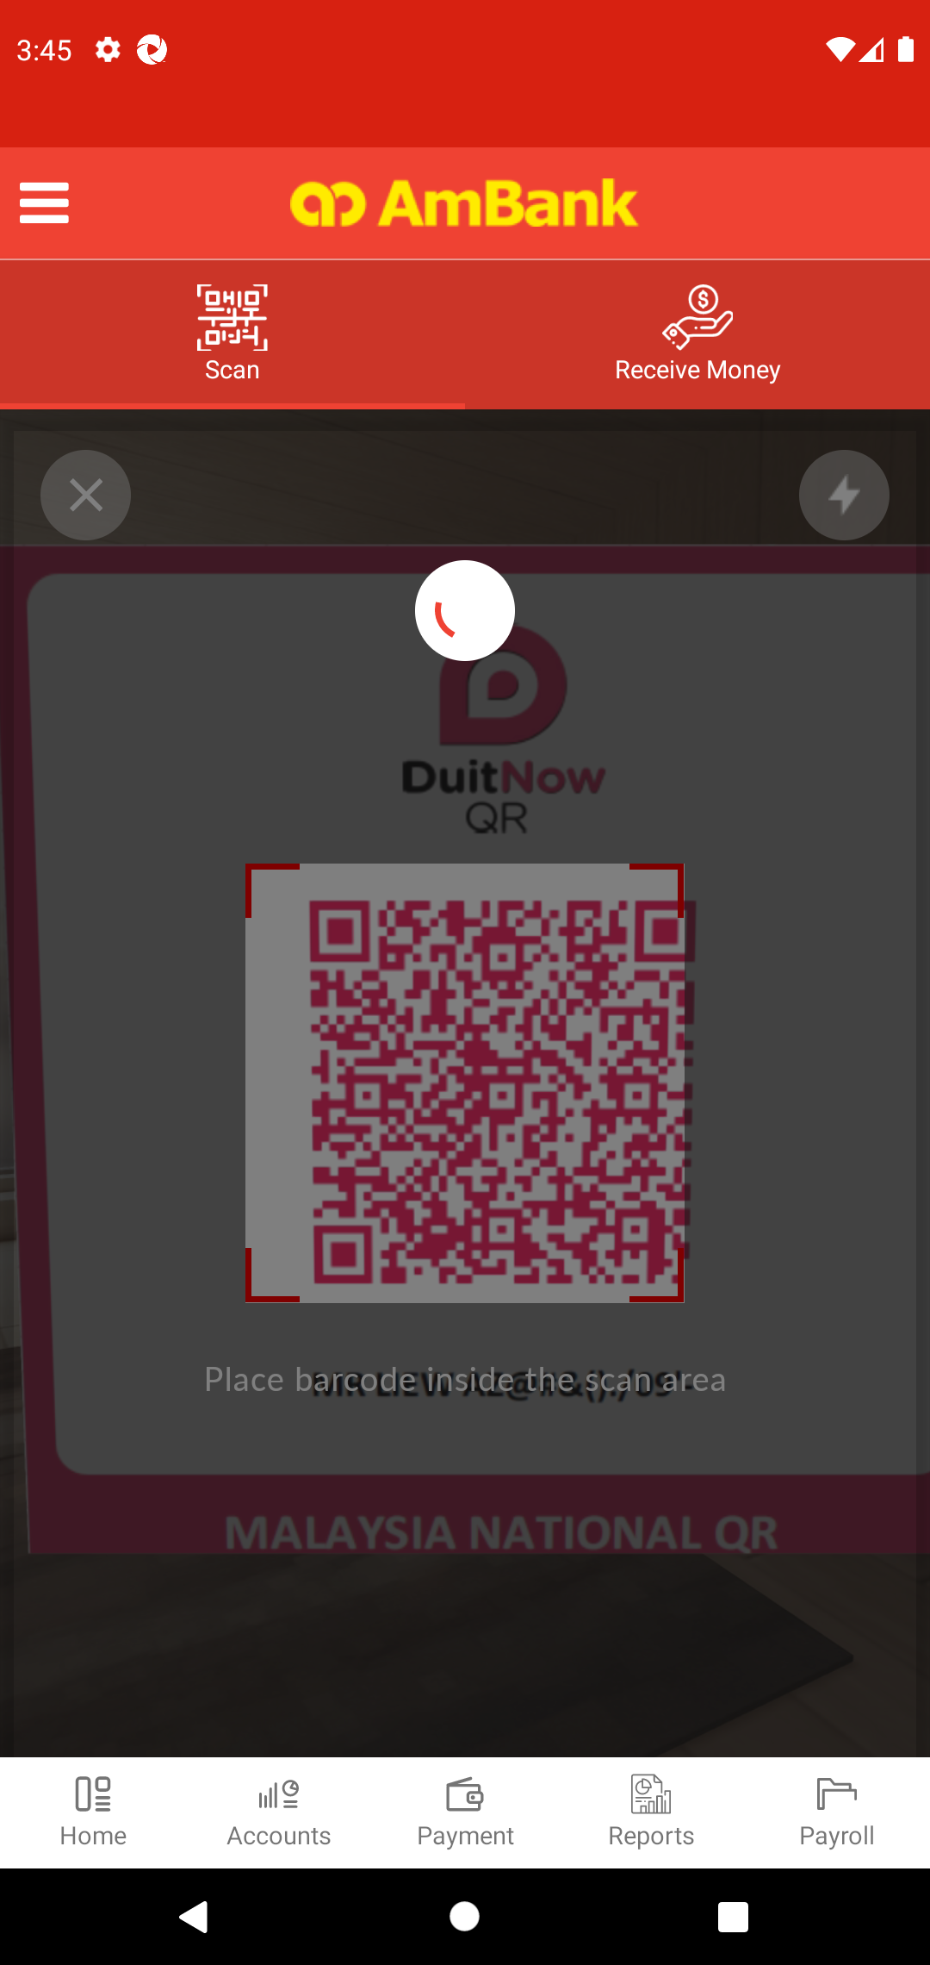  
  
**Test Step 18(PASS) :** Swipe Up to Recipient Resident Status  
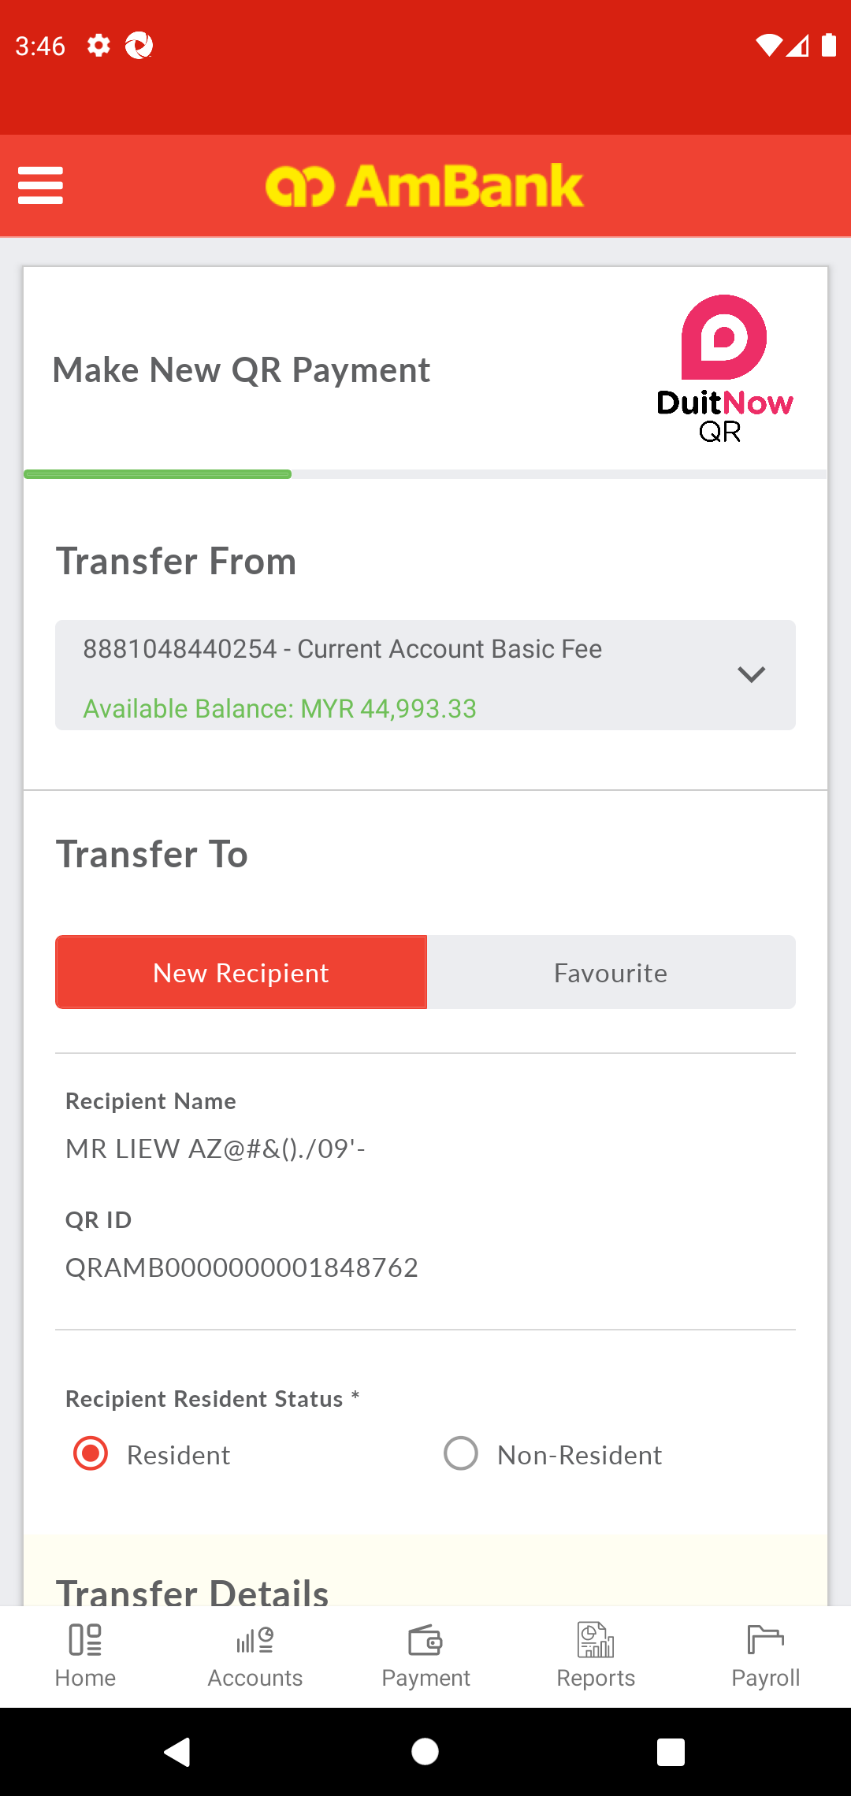  
  
**Test Step 19(PASS) :** [QRPAY] Select [Recipient Resident Status]  
  
  
**Test Step 20(PASS) :** Swipe Up to Amount  
  
  
**Test Step 21(PASS) :** [QRPAY] Input [Amount]  
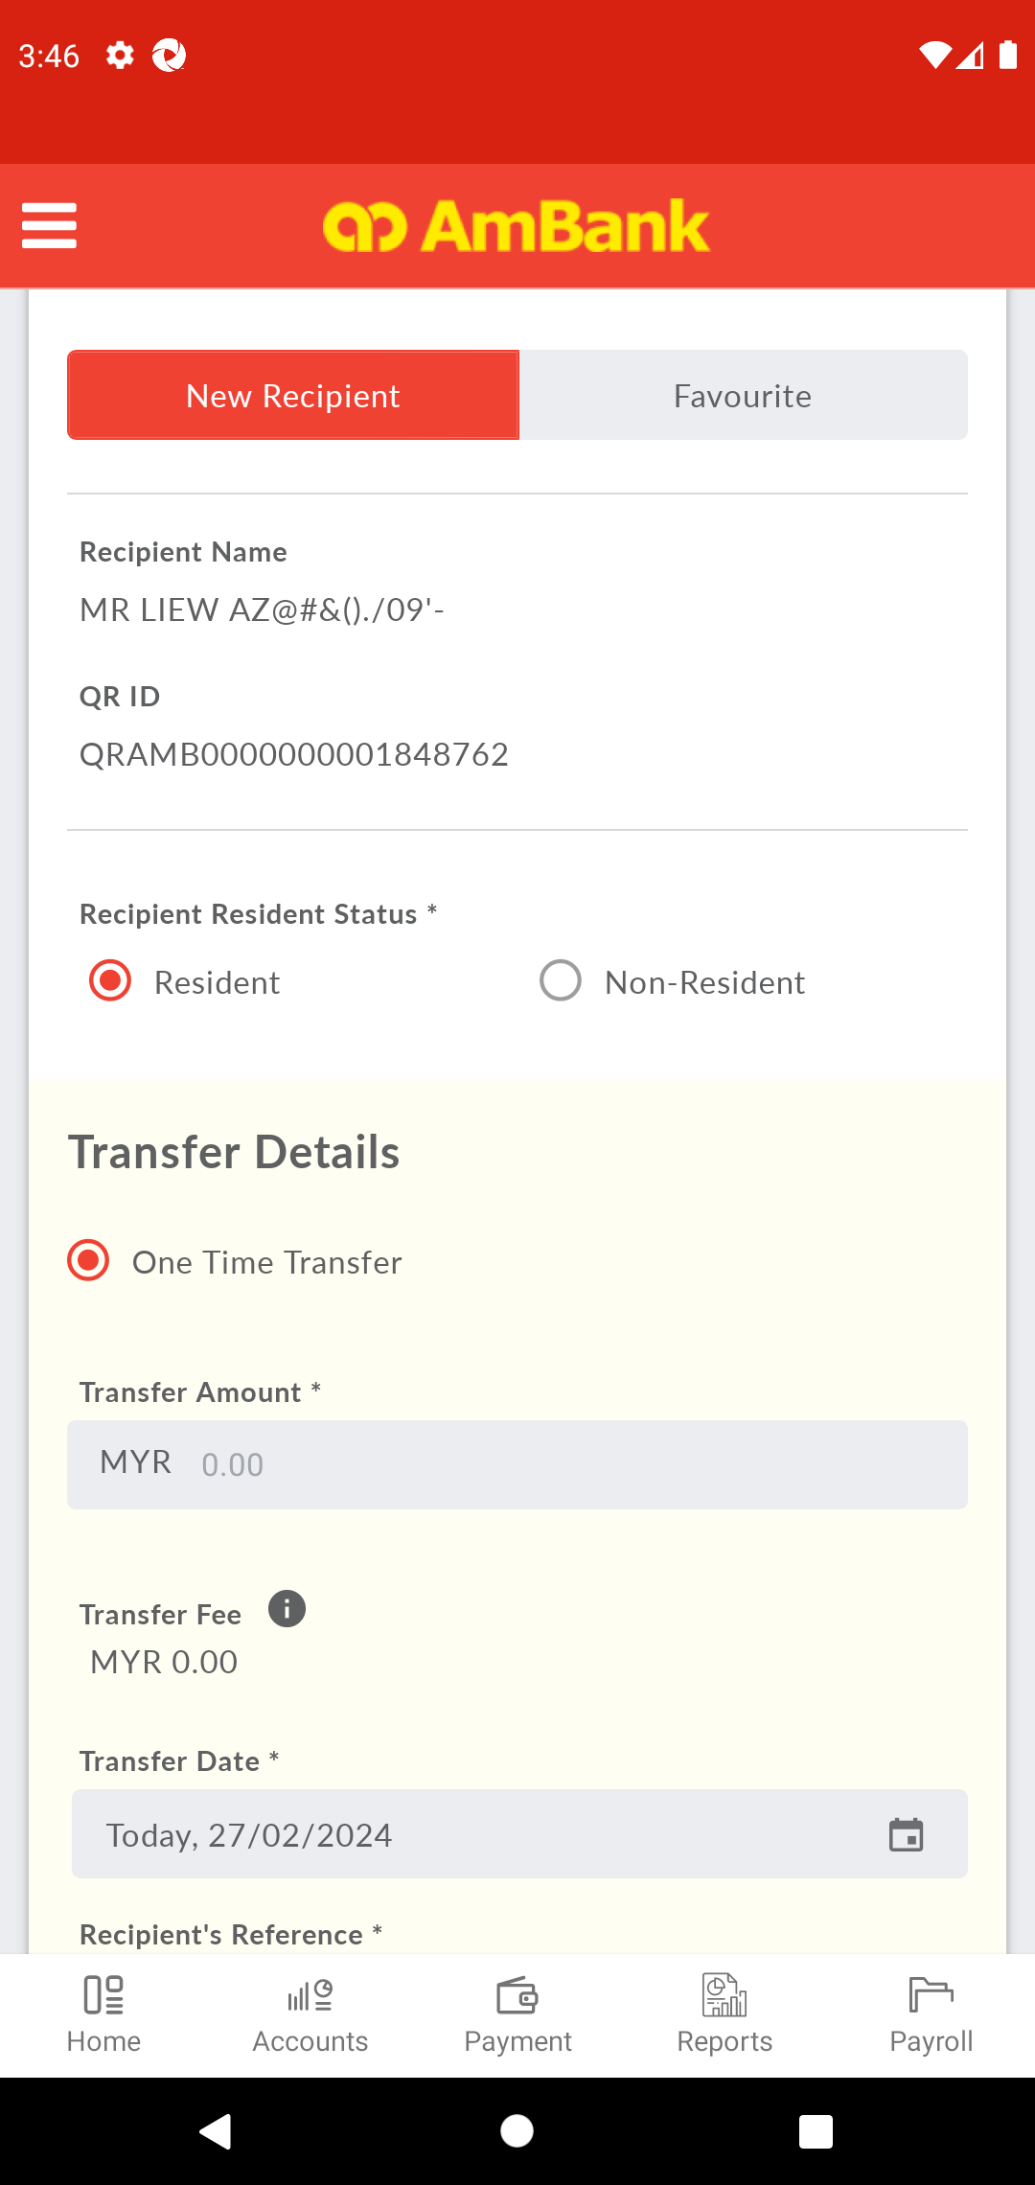  
  
**Test Step 22(PASS) :** Swipe Up to Date  
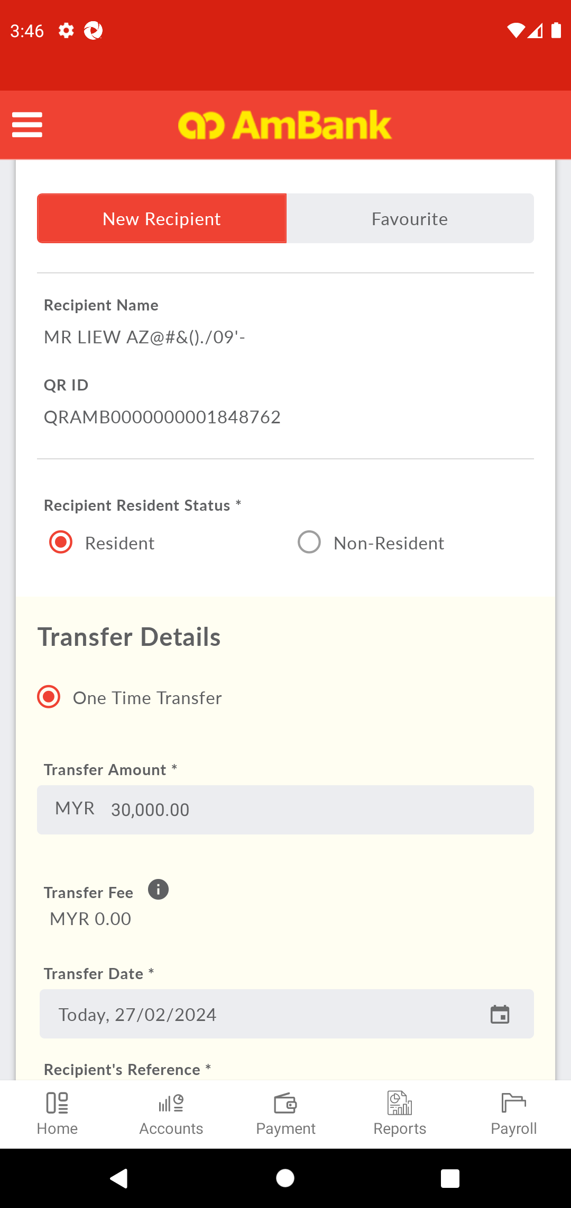  
  
**Test Step 23(PASS) :** [CFO] Click [Date]  
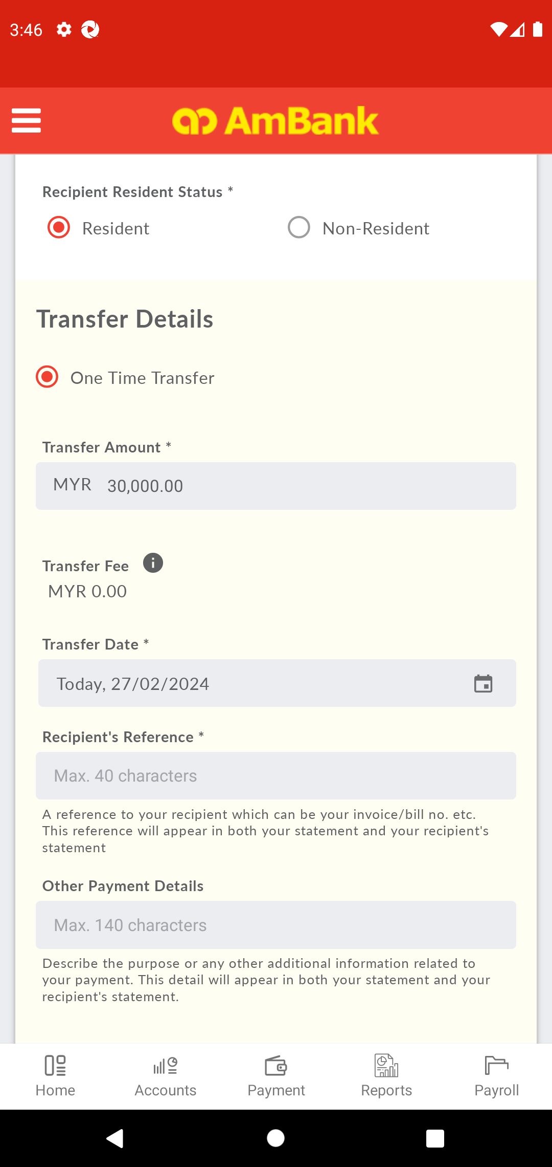  
  
**Test Step 24(PASS) :** [Local Transfer] Select [Date]  
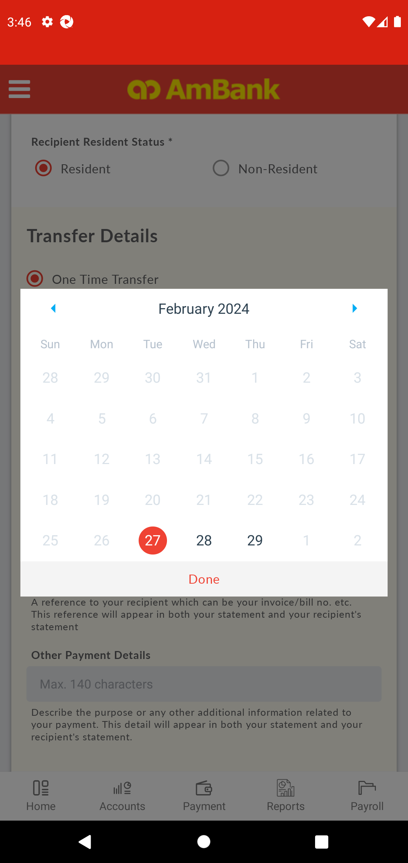  
  
**Test Step 25(PASS) :** [CFO] Click [Done]  
  
  
**Test Step 26(PASS) :** Swipe Up to Other Payment Details  
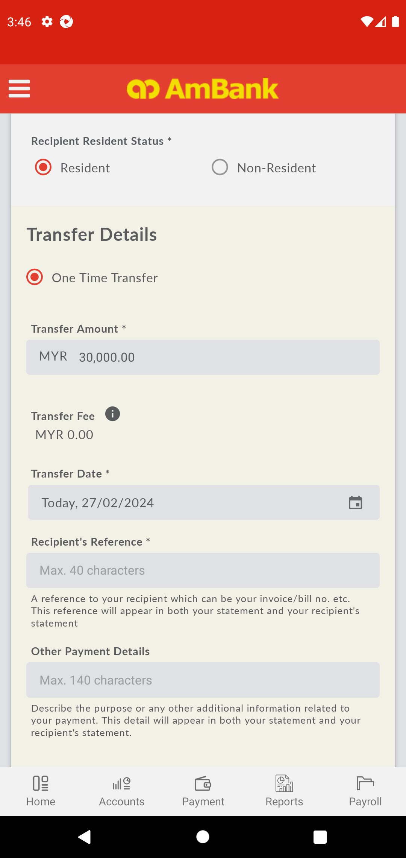  
  
**Test Step 27(PASS) :** [QRPAY] Input [Recipient Reference]  
  
  
**Test Step 28(PASS) :** Swipe Up to Next  
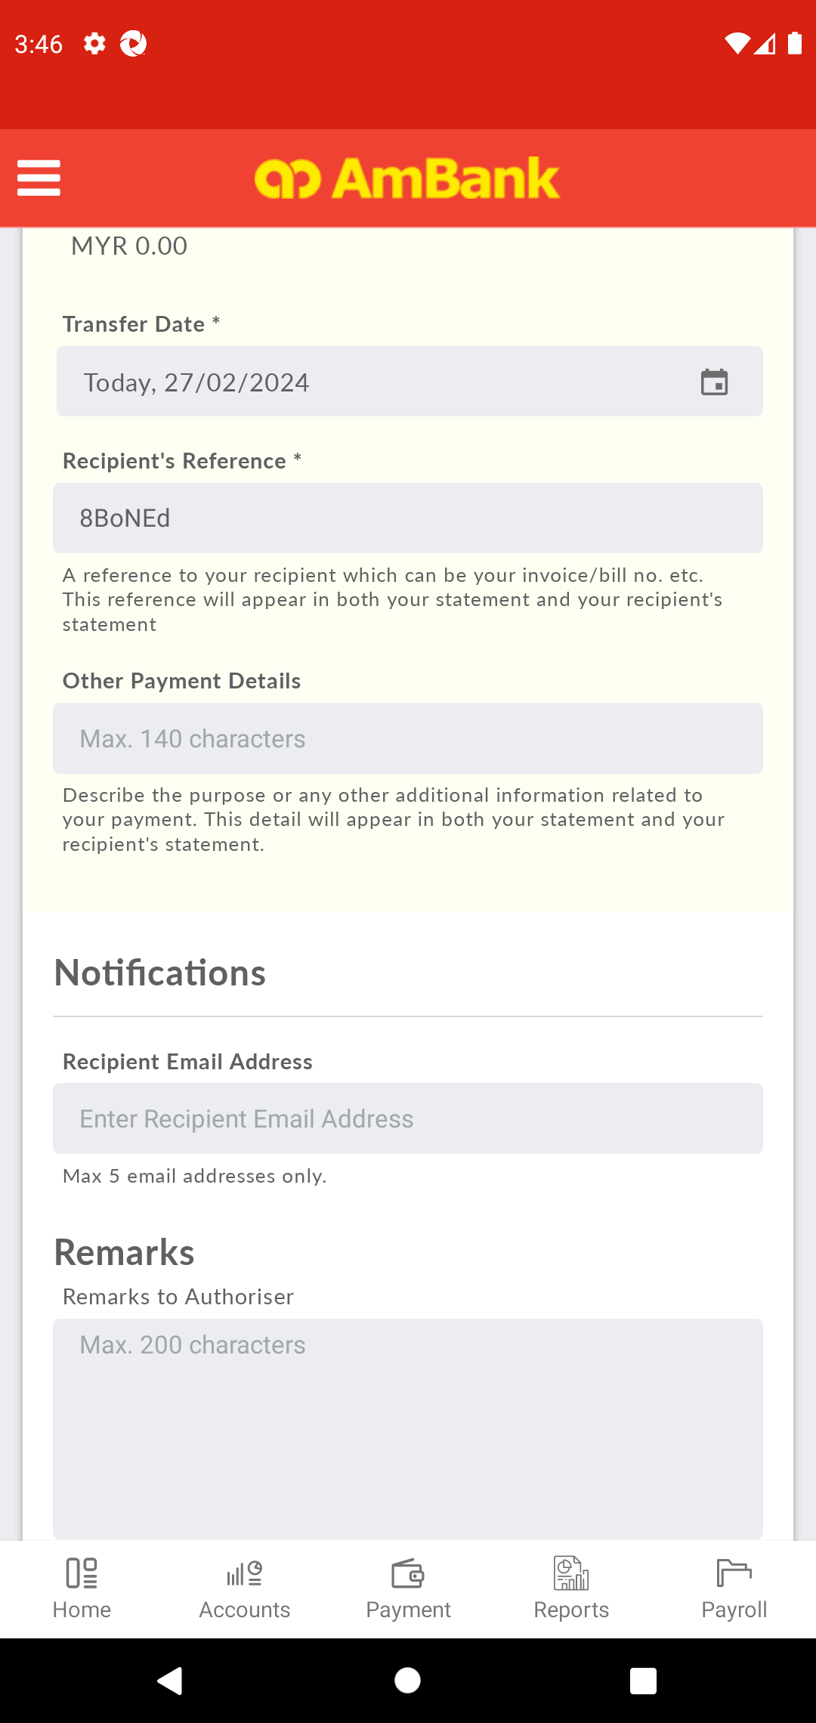  
  
**Test Step 29(PASS) :** [QRPAY] Input [Remarks]  
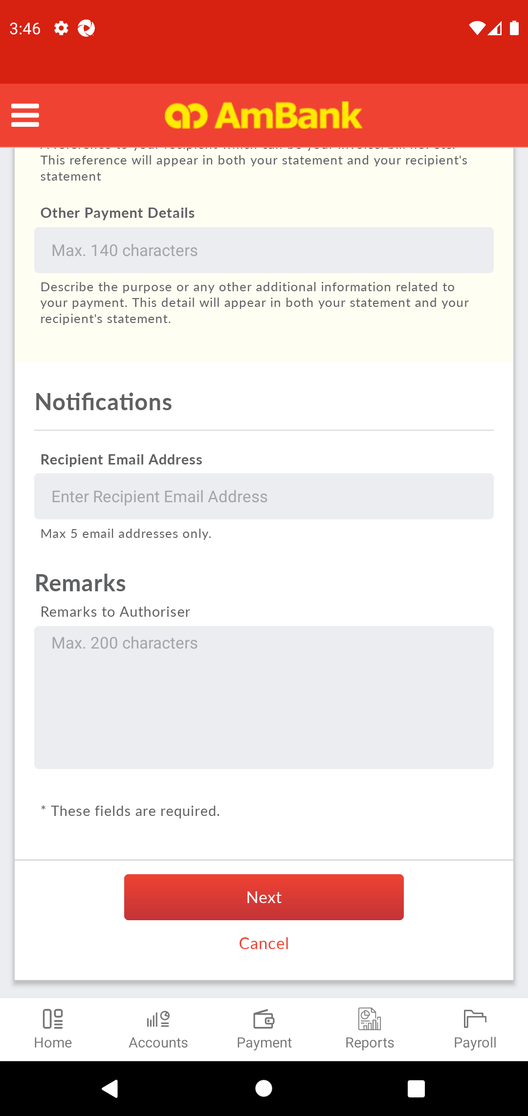  
  
**Test Step 30(PASS) :** [QRPAY] Click [Next]  
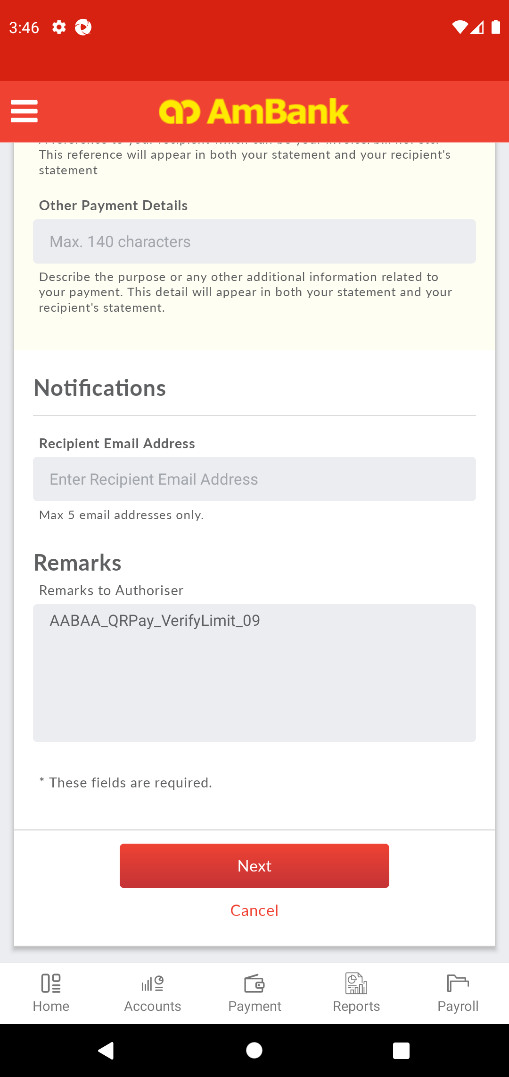  
  
**Test Step 31(PASS) :** [CFO] Verify [Status]  
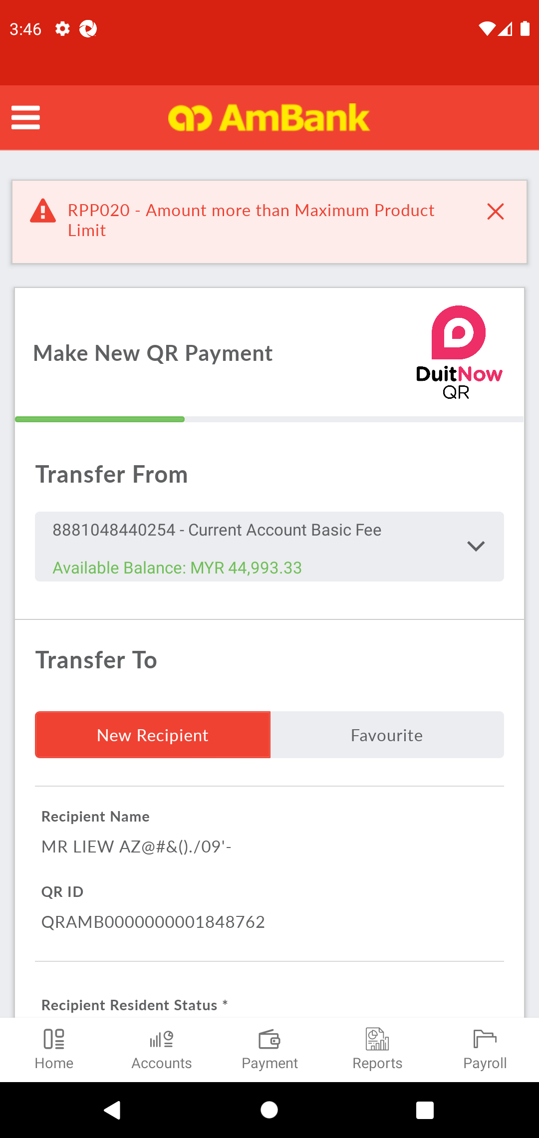  
  
**Test Step 32(PASS) :** Success Log Out  
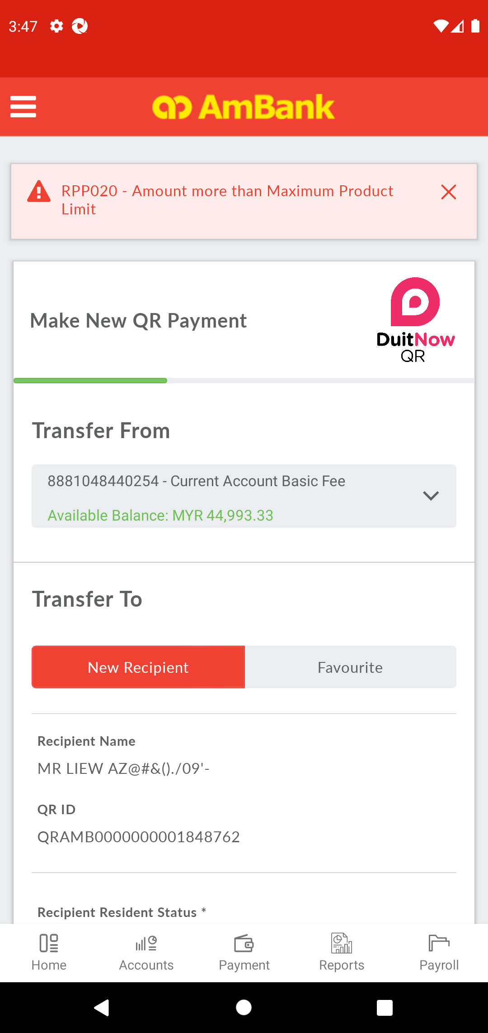  
  
**---------------------------------------- The End ----------------------------------------**